**CHAPTER ONE**

**INTRODUCTION**

**1.0 Overview of the Study**

Establishments like IT firm, Schools, hospitals, government secretarial, financial institution etc. which have large numbers of customers or client received enormous amount of complains per day, and these complain has to be documented and filed for access and stored for future reference. A complaint system (also known as a conflict management system, internal conflict management system, integrated conflict management system or dispute system) is a set of procedures used in organizations to address complaints and resolve disputes.

Complaint Management System Software allows for greater compatibility and accessibility by all personnel of the system by providing a great deal of IT solution through our web services.

Complain Management System Software is one of latest productivity enhancement tools used widely by all organizations wherever there is a need of booking of complaints via operators and analysis of complaints which are made or are pending.

**1.1 Background of the Study**

An academic growth can be of various concerns in academic environment to promote social and functioning educational system. For an effective educational system to take place there are some issues in academic environment that should be properly addressed, take for instance issue of complaints management system in the polytechnic. This issue had created a lot of problems for an academic growth in the various aspects of the educational system. To support this approach, this project identifies a range of options that can be used to manage and resolve Academic complaints. This includes, where the opportunity presents itself, the need for administrator to make every effort to resolve potential or actual academic complaints as informally as possible in the first instance.

Handling complaints often involve first, to listen and understand, empathize, offer a solution, execute the solution and then follow up. Dogan and Wilkinson (2016) defined complaint as any expression of dissatisfaction about services(s) or about any professional conduct. It prompts more prominent clarity and consistency of executive activities to determine the protests. Design and implementation of online complaint management system is to maintain an effective, timely, and equitable complaint handling system which is easily accessible and offered to complainants (students) at no charge. A computerized complaint system can generally collect complaints, store them and these records are collected by the appropriate authority and then decide on the next step to be taken in solving the issues. In relation to the above preposition by Marcus, it is possible for the design and implementation of an online complaint management system to yield substantial benefits for the users (Marcus, 2000).

* 1. **Statement of the Problem**

During the analysis and data collection of this project, it was discovered that there existed a manual form of collecting and storing student’s complaints in other for them to be attended to, and for future purpose by the Students Affairs Department of the Imo State Polytechnic. That is to say that the process of daily task and activities are done manually which is quite unfortunate; manual procedural for complains execution delays and reduces result output quality. Manual complain record keeping has resulted in many setbacks to the expected standard.  The setback encountered includes:

* Time wastage and long quarries.
* Partial or total loss of file or documents.
* Under recording of criminal analysis.
* Exposures of confidential matters.
  1. **Aim And Objectives of the Study**

The main aim of this project is to design an online student complaint management system that will manage student complaints of Imo state polytechnic.

Specific objectives includes:

* To model a computerized complain system to enable proper complain submitting and control.
* To upgrade from manual student complaint management to computerize student complaint management.
* Review an overall study and analysis of online student complaint system
  1. **Significant of the Study**

This study will improve the database, enhance effectiveness, efficiency, and security of the existing system. It is also intended that the study will help in the development of a new and hopefully a standard better computer-aided system.

The new system will improve response time, reduce improper handling of complaint system and also improve the relationship between student, lecturer and management.

* 1. **Scope of the Study**

The scope of this project is limited to the Students Affairs Department of Imo State Polytechnic. Emphasis is laid on the unit that oversees student’s complaints headed by Mr. Iwuanyanwu Uzoma, Dean of student affairs.

* 1. **Limitation of the Study**

The limitation of this project work is that the application will not process the penalties or the punishment for any staff or student found being at fault of any complaints. Other limitations are as follows:

1. The initial difficulty of grasping the knowledge of this field.
2. Inadequate financial resources and the expenses made when photocopying some important and relevant material used in carrying out this research.
3. Time, energy consumed and high cost of transportation made when sourcing out different information about the research.
   1. **Definition of Terms**

To fully understand what the study is all about, important and dispensable terms have been chosen and due definition given to them.

**Computer:** This is an electronic device operated under the control of instruction stored in its memory unit which can accept and store data for future use as well as produce output from the processing.

**Complaint:**An expression of discontent, regret, pain, censure, resentment, or grief; lament, faultfinding a cause of discontent, pain, grief e.t.c. The act of expressing discontent or unhappiness about a situation (Microsoft Encarta2009)

**Online:** It is the condition of being connected to a network of computers or other devices.

**Manually**: Done, Operated, Worked, e.t.c by the hand or hands rather than by an electronic or electrical device.

**Procedure:** An established or correct method of doing something (Microsoft Encarta 2009).

**Computerized:** To control, perform, or store (a system operation or information) by means of an electronic Computer.

**Discrimination:** Unfair treatment of one person or group, usually because of prejudice about race, ethnicity, age, religion, or gender (Microsoft Encarta 2009)

**Inefficiency:**The state of not achieving maximum productivity; failure to make the best use of time or resources.

**Information Storage:**Information storage is an act of a system that keeps data accessible to the information processors; the information storage unit is either a hard drive or a server that usually contains a database.

**Retrieval:**the action of obtaining or consulting material stored in a computer system.

**CHAPTER TWO**

**LITERATURE REVIEW**

**2.0 Introduction**

This project concentrates on the design and implementation of online complaint management system. Such as any general public or government needs laws to govern the procedure among its citizen, a college, as well, needs regulations to characterize the procedure among its students, academic regulations ought to both involve the faculty's requirements for a complaint and give student the rules to achieving their individual goals or objectives; they have to give an intends to student to consider their improvement and for staff to monitor the relative execution of different student. In this manner, student regulations ought to give certifications to student as of now selected and the individuals who look for affirmation that however many controls as could reasonably be expected will be accessible inside the Polytechnic in other to abstain from being grieved.

Complaint managing should be specifically designed with attention on academic part affected by the student. A complaint management system is one of the latest productivity enhancement tools used widely by all organizations whenever there is need of booking of complaints via operators and analysis of complaints which are made or are pending.

**2.1 Conceptual Framework**

**2.1.1 Definition of an Academic Complaint**

An academic complaint refer to a move made by a student against a member of the faculty, colleagues, a part-time instructors or lecturer, a teaching or lecturer assistant, security, or an administrator that allegedly either violates a university, college, or department academic policy or procedure or mostly treats the student on the premise of race, state origin, religious conviction, sex, age, handicap, veteran status, or some other non-academic standing not secured under the college procedure as for sexual behavior or other major college strategies or policies.

Since engaging an evaluation or assessing a student's work or performance includes the faculty's professional decision and is a necessary piece of the faculty' instructing obligations Leat (2007), a complaint is an expression of dissatisfaction or a complaint of a worker and who usually deal with the application, explanation, presentation or moving a statutory right or a procedure, law, custom, working practice or existing agreement.

According to University of Cambridge manual (2016) student complaint procedure allows student to express dissatisfaction about the standard of service provided by the university and it is entitled to any matriculated student.

**2.1.2 Categories of an Academic Complaint**

1. Academic complaint
2. Non-academic complaint

There are formal methods for student to take in the process that they have a complaint or issues. The formal position regarding to a request against grades rewarded that is allowed and that Board of Examiners’ making on examination decisions results are final. Nevertheless, the Board revealed clear confirmation that this approach was not connected consistently over the University. In testing this matter, the Panel realizes that work can be re-marked and grades changed by virtue of conceivable error of marks or slips in grading. At the same time a few student were clearly welcomed to look for a survey of evaluations on events; others had their work re-stamped. Course documentation assessed by the board refers to the strategies for students to claim against evaluation results. What's more the staff position on whether students can advance was conflicting.

The University observes that student may wish to raise a complaint, problem, Issues or concern detecting with their present or past association with the University. Complaint can be about any number of difficulties including matters that may influence a student's feeling of wellbeing and security.

**2.1.2.1 Academic Complaint**

A sincere issue or concern of an academic or non-academic nature raised by an enlisted student or potential student, which is accepted by that student, recognize with student academic advancement, assessment, educational module, nature obviously delivery, academic accomplishment in a course and awards.

**Others include:**

1. Appeal of grading decision (e.g. failure of an assessment piece or subject)
2. Elimination from study or continual enrolment
3. Findings of accusations of academic student misconduct (e.g. cheating or plagiarism)
4. Quality of course conveyance
5. Outcomes of credit transfer

**2.1.2.2 Non-Academic Complaint**

Protest/s which do not identify with student improvement, evaluation, educational program and rewards in a course of study. Non-Academic Complaints combines protests in connection to the following:

* + 1. Discrimination
  1. Shamefulness and injustice treatment
  2. Sexual harassment, other types of harassment
  3. Student amenities
  4. Worries about grounds offices, environment, well-being and security or equipment and so forth.

**2.1.3 History of Complaint System**

There is a substantial early history of scholarly work on [due process](https://en.wikipedia.org/wiki/Due_process), and union and non-union [grievance procedures](https://en.wikipedia.org/wiki/Grievance_(labour)) within organizations. This work focused primarily on [rights](https://en.wikipedia.org/wiki/Rights)-based [conflict resolution](https://en.wikipedia.org/wiki/Conflict_resolution) between union and non-union workers and their managers. Scholarly work has evolved to cover both a wider range of conflict management channels, and, also, a much wider range of disputants.

In the 1970s and 1980s much interest arose in the United States, in dealing with conflict informally as well as formally, and in learning from conflict and managing conflict. In contemporary language, these discussions centered on the "interests" of all who would consider themselves stake-holders in a given conflict and on systems change as well as resolving grievances.

These discussions led to questions of how to think about complaint systems and how to link different conflict management offices and processes within an organization. Papers by Ronald Berenbeim 1980, Mary Rowe, and Michael Baker, described a systems approach for dealing with complaints and all kinds of disputes within organizations.

Many authors extended the work of Berenbeim, Rowe, and Rowe and Baker, on the topic of internal complaint systems. They included: Douglas M. McCabe, [William L. Ury](https://en.wikipedia.org/wiki/William_L._Ury), Jeanne M. Brett, and Stephen B. Goldberg. (Ury, Brett and Goldberg in particular described conflict resolution within organizations in terms of interests, rights and power and the possibility of looping back from rights-based processes to interest-based solutions.) Cathy Costantino and Cristina S Merchant, and Karl A. Slaikeu and Ralph H. Hasson extensively explored issues of designing conflict management systems.

The concept of an integrated conflict management system was conceived and developed by Mary Rowe, in numerous articles in the 1980s and 1990s. She saw the need to offer options for complainants and therefore a linked system of choices within an organizational system.

The idea of a systems approach has endured well. In recent years however, there has been discussion as to whether conflict should be "managed" by the organization or whether the goal is to understand, deal with and learn from conflict. There is also concern about practical and theoretical issues in "integrating" a system, with some observers preferring the idea of "coordinating" a conflict system. However 2012 research by David Lipsky *et al.*, suggests that an increasing number of corporations see themselves as having "integrated conflict management systems," or "ICMS."

There is also a major need to collect, review and understand the nature of conflict management and complaint systems around the world. Studies and citations are needed about how complaint systems work for women as well as men. Research is needed as to how systems work for many different national groups, for people of different socio-economic classes, and different ages, and different religions, and especially for contract workers and immigrant workers, in every country. Studies (and citations) are needed about complaint systems in health care, in faith-based organizations, in schools, in political organizations, in the military and in many specialized occupations. Studies are needed about important specialized issues like free speech.

A number of [artificial intelligence](https://en.wikipedia.org/wiki/Artificial_intelligence) technologies are helpful in complaint resolution process, understanding the attitudes of involved parties and reasoning about them, in particular, based on the [belief–desire–intention model](https://en.wikipedia.org/wiki/Belief%E2%80%93desire%E2%80%93intention_model). Concept learning is an adequate formalism to reason about complaints.

**2.2 Review of Related Literature**

### **2.2.1 Early Conflict Management Models**

Blake and Mouton (1964) were among the first to present a conceptual scheme for classifying the modes (styles) for handling interpersonal conflicts in five types: forcing, withdrawing, smoothing, compromising, and problem solving.

In the 1970s and 1980s, researchers began using the intentions of the parties involved to classify the styles of conflict management that they included in their models. Both Thomas (1976) and Pruitt (1983) put forth a model based on the concerns of the parties involved in the conflict. The combination of the parties' concern for their own interests (i.e. [assertiveness](https://en.m.wikipedia.org/wiki/Assertiveness)) and their concern for the interests of those across the table (i.e. cooperativeness) yielded a particular conflict management style. Pruitt called these styles yielding (low assertiveness/high cooperativeness), problem solving (high assertiveness/high cooperativeness), inaction (low assertiveness/low cooperativeness), and contending (high assertiveness/low cooperativeness). Pruitt argues that problem-solving is the preferred method when seeking mutually beneficial options (win-win).

### **Khun and Poole's Model**

Khun and Poole (2000) established a similar system of group conflict management. In their system, they split Kozan's confrontational model into two sub models: distributive and integrative.

1. Distributive – Here conflict is approached as a distribution of a fixed amount of positive outcomes or resources, where one side will end up winning and the other losing, even if they do win some concessions.
2. Integrative – Groups utilizing the integrative model see conflict as a chance to integrate the needs and concerns of both groups and make the best outcome possible. This model has a heavier emphasis on compromise than the distributive model. Khun and Poole found that the integrative model resulted in consistently better task related outcomes than those using the distributive model.

### **Dechurch and Marks's Meta-Taxonomy**

DeChurch and Marks (2001) examined the literature available on conflict management at the time and Ni established what they claimed was a "meta-taxonomy" that encompasses all other models.

They argued that all other styles have inherent in them into two dimensions:

1. Activeness ("the extent to which conflict behaviors make a responsive and direct rather than inert and indirect impression"). High activeness is characterized by openly discussing differences of opinion while fully going after their own interest.
2. [agreeableness](https://en.m.wikipedia.org/wiki/Agreeableness) ("the extent to which conflict behaviors make a pleasant and relaxed rather than unpleasant and strainful impression"). High agreeableness is characterized by attempting to satisfy all parties involved.

In the study DeChurch and Marks conducted to validate this division, activeness did not have a significant effect on the effectiveness of conflict resolution, but the agreeableness of the conflict management style, whatever it was, did have a positive impact on how groups felt about the way the conflict was managed, regardless of the outcome.

### **Rahim's Meta-Model**

Rahim (2002) noted that there is agreement among management scholars that there is no one best approach to how to make decisions, lead or manage conflict.

In a similar vein, rather than creating a very specific model of conflict management, Rahim created a meta-model (in much the same way that DeChurch and Marks, 2001, created a meta-taxonomy) for conflict styles based on two dimensions, concern for self and concern for others.

Within this framework are five management approaches: integrating, obliging, dominating, avoiding, and compromising.

1. Integration involves openness, exchanging information, looking for alternatives, and examining differences so solve the problem in a manner that is acceptable to both parties.
2. Obliging is associated with attempting to minimize the differences and highlight the commonalities to satisfy the concern of the other party.
3. Dominating in this style one party goes all out to win his or her objective and, as a result, often ignores the needs and expectations of the other party.
4. Avoiding here a party fails to satisfy his or her own concern as well as the concern of the other party.
5. Compromising involves give-and-take whereby both parties give up something to make a mutually acceptable decision.

**2.3 Theoretical Framework**

**2.3.1 Conflict Management**

**Conflict management** is the process of limiting the negative aspects of [conflict](https://en.m.wikipedia.org/wiki/Conflict_(process)) while increasing the positive aspects of conflict. The aim of conflict management is to enhance [learning](https://en.m.wikipedia.org/wiki/Learning) and group outcomes, including effectiveness or performance in an organizational setting. With better enhancements properly managed conflict can improve group outcomes.

[Conflict resolution](https://en.m.wikipedia.org/wiki/Conflict_resolution) involves the reduction, elimination, or termination of all forms and types of conflict. Five styles for conflict management, as identified by Thomas and Kilmann, are: competing, compromising, collaborating, avoiding, and accommodating.

Businesses can benefit from appropriate types and levels of conflict. That is the aim of conflict management, and not the aim of conflict resolution. Conflict management does not imply conflict resolution.

Conflict management minimizes the negative outcomes of conflict and promotes the positive outcomes of conflict with the goal of improving learning in an organization.

Properly managed conflict increases [organizational learning](https://en.m.wikipedia.org/wiki/Organizational_learning) by increasing the number of questions asked and encourages people to challenge the status quo.

## [Organizational conflict](https://en.m.wikipedia.org/wiki/Organizational_conflict) at the interpersonal level includes disputes between peers as well as supervisor-subordinate conflict. [Party-directed mediation](https://en.m.wikipedia.org/wiki/Party-directed_mediation) (PDM) is a mediation approach particularly suited for disputes between co-workers, colleagues or peers, especially deep-seated interpersonal conflict, multicultural or multiethnic disputes. The mediator listens to each party separately in a pre-caucus or pre-mediation before ever bringing them into a joint session. Part of the pre-caucus also includes coaching and role plays. The idea is that the parties learn how to converse directly with their adversary in the joint session. Some unique challenges arise when organizational disputes involve supervisors and subordinates. The Negotiated Performance Appraisal (NPA) is a tool for improving communication between supervisors and subordinates and is particularly useful as an alternate mediation model because it preserves the hierarchical power of supervisors while encouraging dialogue and dealing with differences in opinion.

## **2.3.2 Orientations to Conflict**

There are three orientations to conflict: lose-lose, win-lose, and [win-win](https://en.m.wikipedia.org/wiki/Win-win). The lose-lose orientation is a type of conflict that tends to end negatively for all parties involved. A win-lose orientation results in one victorious party, usually at the expense of the other. The win-win orientation is one of the most essential concepts to conflict resolution. A win-win solution arrived at by integrative bargaining may be close to optimal for both parties. This approach engages in a [cooperative](https://en.m.wikipedia.org/wiki/Cooperation) approach rather than a competitive one.

Although the win-win concept is the ideal orientation, the notion that there can only be one winner is constantly being reinforced in American culture:

"The win-lose orientation is manufactured in our society in athletic competition, admission to academic programs, industrial promotion systems, and so on. Individuals tend to generalize from their objective win-lose situations and apply these experiences to situations that are not objectively [fixed-pies](https://en.m.wikipedia.org/wiki/Lump_of_labour_fallacy)".

This kind of mentality can be destructive when communicating with different cultural groups by creating barriers in negotiation, resolution and compromise; it can also lead the "loser" to feel mediocre. When the win-win orientation is absent in negotiation, different responses to conflict may be observed.

**2.4 Benefit of Having an Internal Online Complaints System**

A good complaint system will provide important response from administrator and will benefit students by:

1. Serving as a fast and efficient means of resolving concerns which may arise to student.
2. Indicating where problem exist in the procurement of managements and strategy of a foundation
3. Highlighting weaknesses in guiding system and zones which may require change
4. It gives student verification that their affirmations or issues are usually considered important and that they are consistently treated appropriately, decently and unbiased.

**2.5** **The Values for Complaints and Appeal Management Policy**

1. Procedural fairness and regular equity;
2. A code of conduct or morals and behaviour;
3. An administration society free from separation and provocation;
4. Straightforward arrangements
5. Avenue for response and further investigation.

The policy Code of Conduct guides the Complaints and Complaints Management Policy and procedures were defined by Ombudsman (2005).

**2.6 Need for Complaint Registration and Appeal System**

To obtain a well-functioning complaint mechanism and appeal registration system, student needs to abide under the following process:

1. Student must be well registered (known) in other to have an account with complaint web application to generate password to login their complaints.
2. Student must know the entire student misbehaviour act provided by the school management/administrator before apply for any appeal.
3. Informing students of the procedure and the policy during their course orientation and counselling students to read it at the beginning of a course.

**2.7 Motivation for Registration and Appeal System**

The previous manual system cannot be easily traced back due to the blunder of data, forms, and some other document. The process below motivate the undertaking analysis of preventing complaint been prolong more than the accurate or normal time of solving it.

The motivation of this system is to undergo the following processes**:**

1. To promote unity between the students to student, staffs and administrator/management.
2. To secure life-threatening protection against non-academic complaints (such as sexual harassment, discrimination, student amenities, unfairness and injustice).
3. To provide an adequate complaint/grievance website that a student can easily login with their student ID or Matric number and password generating from the complaint control system and issue a complaint for a proper addressing from the management.
4. Students will have chances to be involved in the processes of approval, progress, monitoring and evaluation of the complaints.
5. Provides a predictable, clear, and credible process to all parties involved, resulting in outcomes that are seen as fair, effective, and fixed.

**CHAPTER THREE**

**RESEARCH METHODOLOGY AND SYSTEM ANALYSIS**

1. **Introduction**

This chapter deals with objects or entities of the system, the goal of the requirements gathering and the analysis phase of this project is to understand a student problems of the existing system and needs which forms the basis of their expectations from the proposed new system. It involves a proper study of the project problem statement, elicitation of the requirements from the intended users and other stakeholders, to produce a requirements definition document and analyzing the requirements thus gathered to determine the specifications of the proposed new system.

**3.1 Research Methodology**

This work was undertaken using Object Oriented Analysis and Design methodology (OOAD). OOAD is a popular technical approach for analyzing and designing an application, system or business by applying object-oriented programming as well as using visual modeling throughout the development life cycles. Also in this chapter, the method data collection, evaluation of the existing system and organization structure of the system problem is presented.

**3.2 Methods of Data Collection**

**3.2.1 Primary Data**

In primary data collection of this work, interview and investigation methods where used for the collection of data.

**3.2.1.1 Interview Method**

Some of the students in the campus and also some of the staff in the student affairs unit where interviewed and they gave me reliable information for the existing system. We choose interview method as one of our method of data collection because it provide personal contact which allows the developer to be responsive and adapt to what the user says thereby producing high quality information.

**3.2.1.2 Investigation Method**

Investigation of the existing system process was made. It involved observing students response via documenting their complaints and manually submitting it to the appropriate office or throw it into the complaint box provided by the department.

Investigation was also use because watching people carry out their work in their natural settings provide the analyst with a better understanding of the job.

**3.2.2 Secondary Data**

During the course of the study, other very useful information where collected from existing sources e.g books, internet and journals. After analysis of the primary data, the result was then compared with the primary data to make a conclusive decision.

**3.3 Analysis of the Existing System**

In the existing system, which is a manual system of complaint report, where aggrieved student will have to document their complaints in a piece of paper which they will have to throw it into the complaint box provided by the department or go to the appropriate office in their department to submit their complaints, then at the end of the day or sometimes weeks, or month, the department we now go to the student affairs department of the polytechnic to submit their complaints. In some cases if the head of student affairs (Mr. Iwuanyanwu Uzoma) is not in the office, the complaints will have to wait until whenever he comes back is back which causes more delay in granting the students their desired justice and it is known that justice delayed is justice denied (Martin Luther King Jr. 1963). Oftentimes, it requires one to know somebody at the top level of the polytechnic in order for one complaints to be properly attended to and on time, which not many students in the polytechnic have such influence.

To add to this, the complaints are submitted to a staff, who may have vested interest on the person on whose behalf the complaints was made. Since the officer will first read through the complaint, this can make or mar the whole process for that student in getting justice. There is no feedback mechanism at all for the student to know for a fact that his/her complaints have been received and timely response is also not guaranteed.

**3.4 Problem of the Existing System**

The present system of complaint report has some numerous drawbacks which includes the following;

1. **Delay in processing of student’s complaints:** Before the student’s complaints will be moved by the department to the Student Affairs Department and the challenge of waiting for the head of the department to be on seat, it may take up to weeks or months which delays the students’ justice.
2. **Lack of security of student’s complaints:** Since the complaints are not properly monitored it may not get to the appropriate office.
3. **No proper documentation:** This generates a lot of records and keeping them can be a problem in a sense that they can be easily mixed up, making retrieval difficult particularly when the appeal are urgently needed for decision making.
4. **No feedback mechanism:** Due to its manual process, students hardly gets feedback that their complaints have been received.

**3.5 Proposed New System**

Because of the problems eminent in the existing system, this research proposes a new complaints report system for the institution. The proposed system will be a computerized system which will enable student to make their complaints online and at their comfort zone once they have internet access.

**3.6 Justification of the New System**

The Online Student Complaint Report System shall ultimately facilitate the processing of students’ complaints. It shall also enable students to make their complaints from any part of the globe since this is an online application available in the internet. Cases of insecurity will be eliminated and there will be easy and fast resolving of students complaints.

**CHAPTER FOUR**

**SYSTEM DESIGN AND IMPLEMENTATION**

* 1. **Introduction**

In this chapter, the system design and implementation is discussed.

System design is the process of defining and developing a system to satisfy specified requirements of the market or customer. System implementation is the delivery of fully tested system into production for its daily operation. This stage involves the writing of computer program, tools and eventually, changes over to the new system.

* 1. **File Design**

Design is a stage/phase in software development lifecycle that answers the question of how will the new system work.

* + 1. **Use Case Diagram**

A use case is a diagram that is used to show or represent the functions or features of the new system. The use case diagram here illustrates the interactions among the students, system administrator and the complaint system.

**Use Case Diagram for Complaint System**

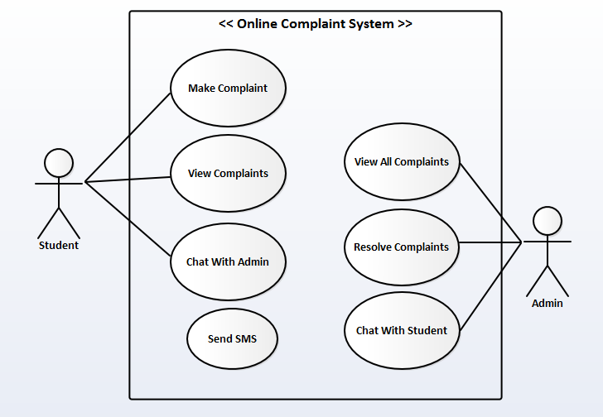

**4.1.1.1 Use Case Description for Make Complaint**

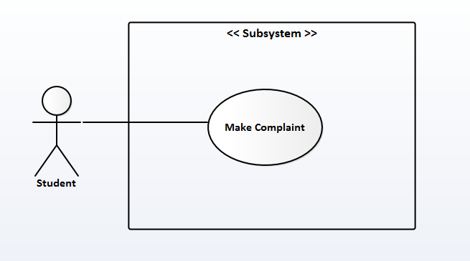

**Title:** Make Complaint

**Purpose:** This feature / functionality allows the primary actor (Student) to make a complaint on any issue.

**Pre-condition(s):** Student must be authenticated.

**Description:**

**Actor Action**  **System Response**

1. Select option to make a complaint 2) Displays a message box for student to type

in their complaint

3)Student types his/her complaints and 4) Displays complaint submitted successfully.

select the complain button

**4.1.1.2 Use Case Description for View Complaint**

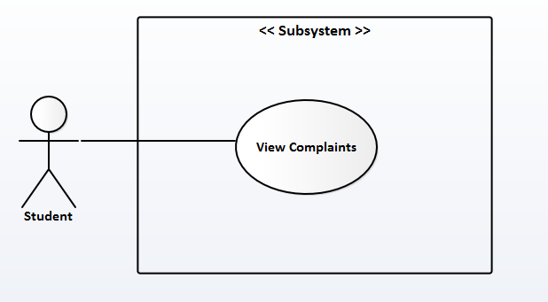

**Title:** View Complaints

**Purpose:** This feature / functionality allows the primary actor (Student) to view his/her complaints

**Pre-Condition(s):** Student must be authenticated and have also made a complaint(s)

**Description:**

**Actor Action** **System Response**

1) Student selects mycomplaints button 2) Displays student complaint(s)

**4.1.1.3 Use Case Description for Chat With Admin**

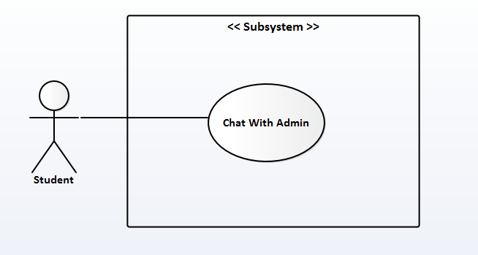

**Title:** Chat with Admin

**Purpose:** This feature / functionality allows the primary actor (Student) to have conversation with the Admin.

**Pre-Condition(s):** Student must be authenticated, have made a complaint(s) and have viewed his/her complaint(s).

Description:

Actor Action System Response

1) Student selects chat button 2) Displays the chatting page for student

to start chatting with Admin

**4.1.2 Activity Diagram**

Activity Diagram is a graphical representation of workflows of stepwise activities and actions with support for choice, iteration and concurrency. Activity diagram is a UML diagram in used to describe the dynamic aspects of the system.

**4.1.2.1 Activity Diagram for Log-In**

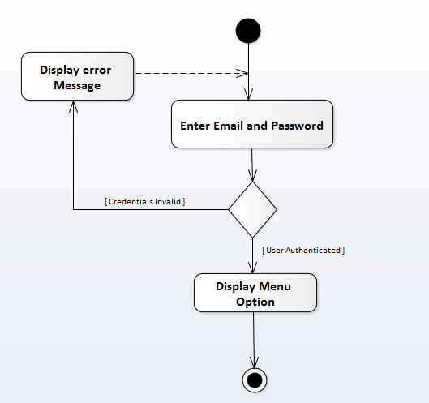

**4.1.2.2 Activity Diagram for Make Complaint**

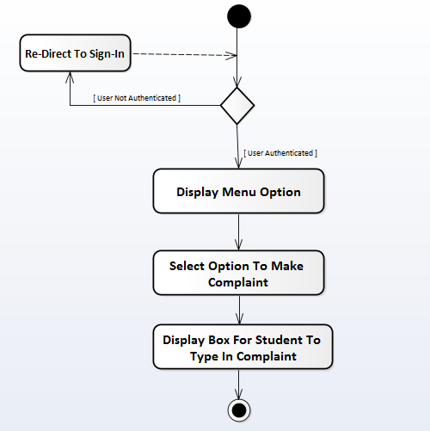

**4.1.2.3 Activity Diagram for View Complaints**

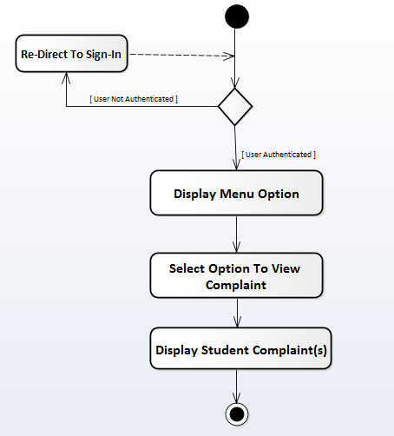

**4.1.2.4 Activity Diagram for Chat With Admin**

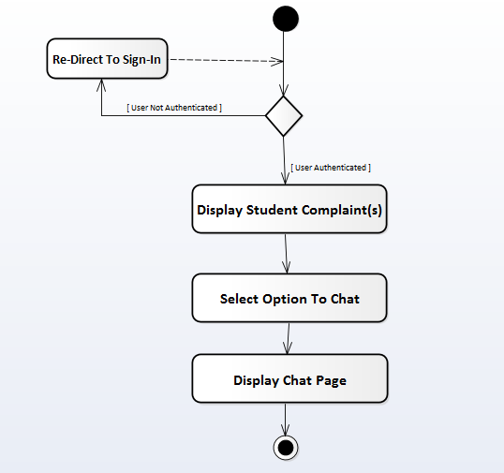

**4.1.3 Class Diagram**

A class diagram models the static structure of a system. It shows the relationships between classes, objects, attributes, and operations.

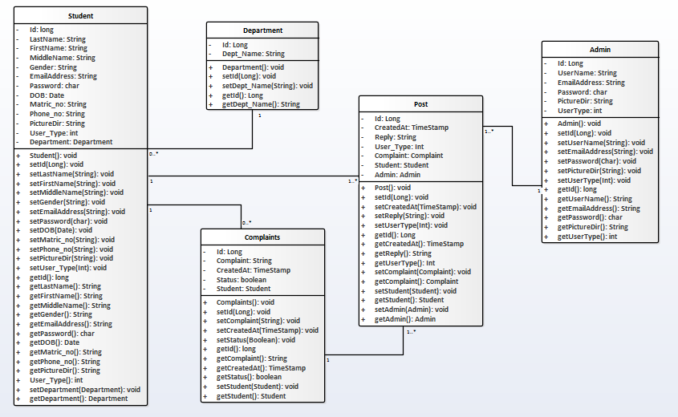

**4.1.4 System Architecture**

System architecture is the conceptual model that defines the structure, behavior, and more views of a system.

**4.1.4.1 Physical Architecture**

The physical architecture is the physical layout of a system and its components in a schema.

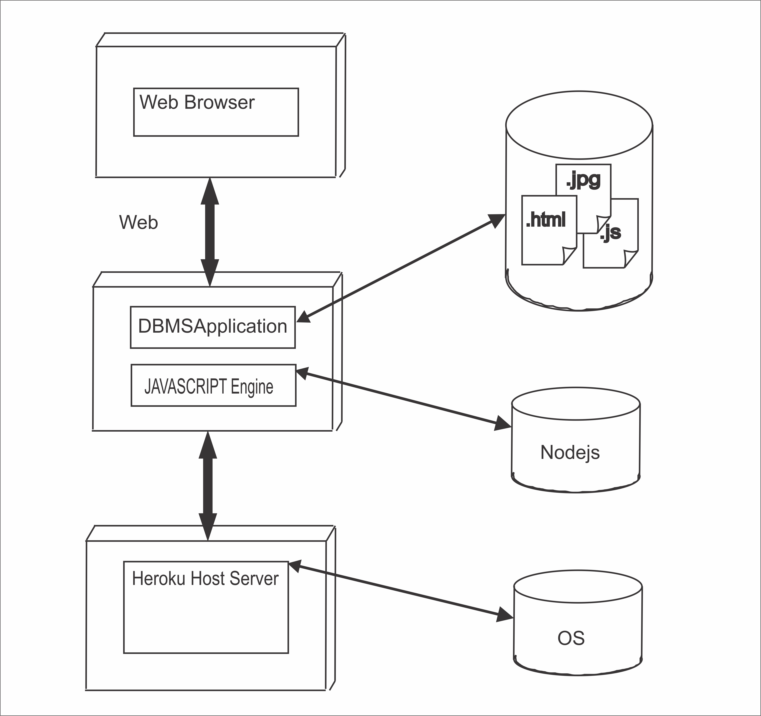

Figure 4.1.4.1: Physical Architecture

**4.1.4.2 Logical Architecture**

A logical design is a more detailed design which includes all major components and entitles plus their relationships.

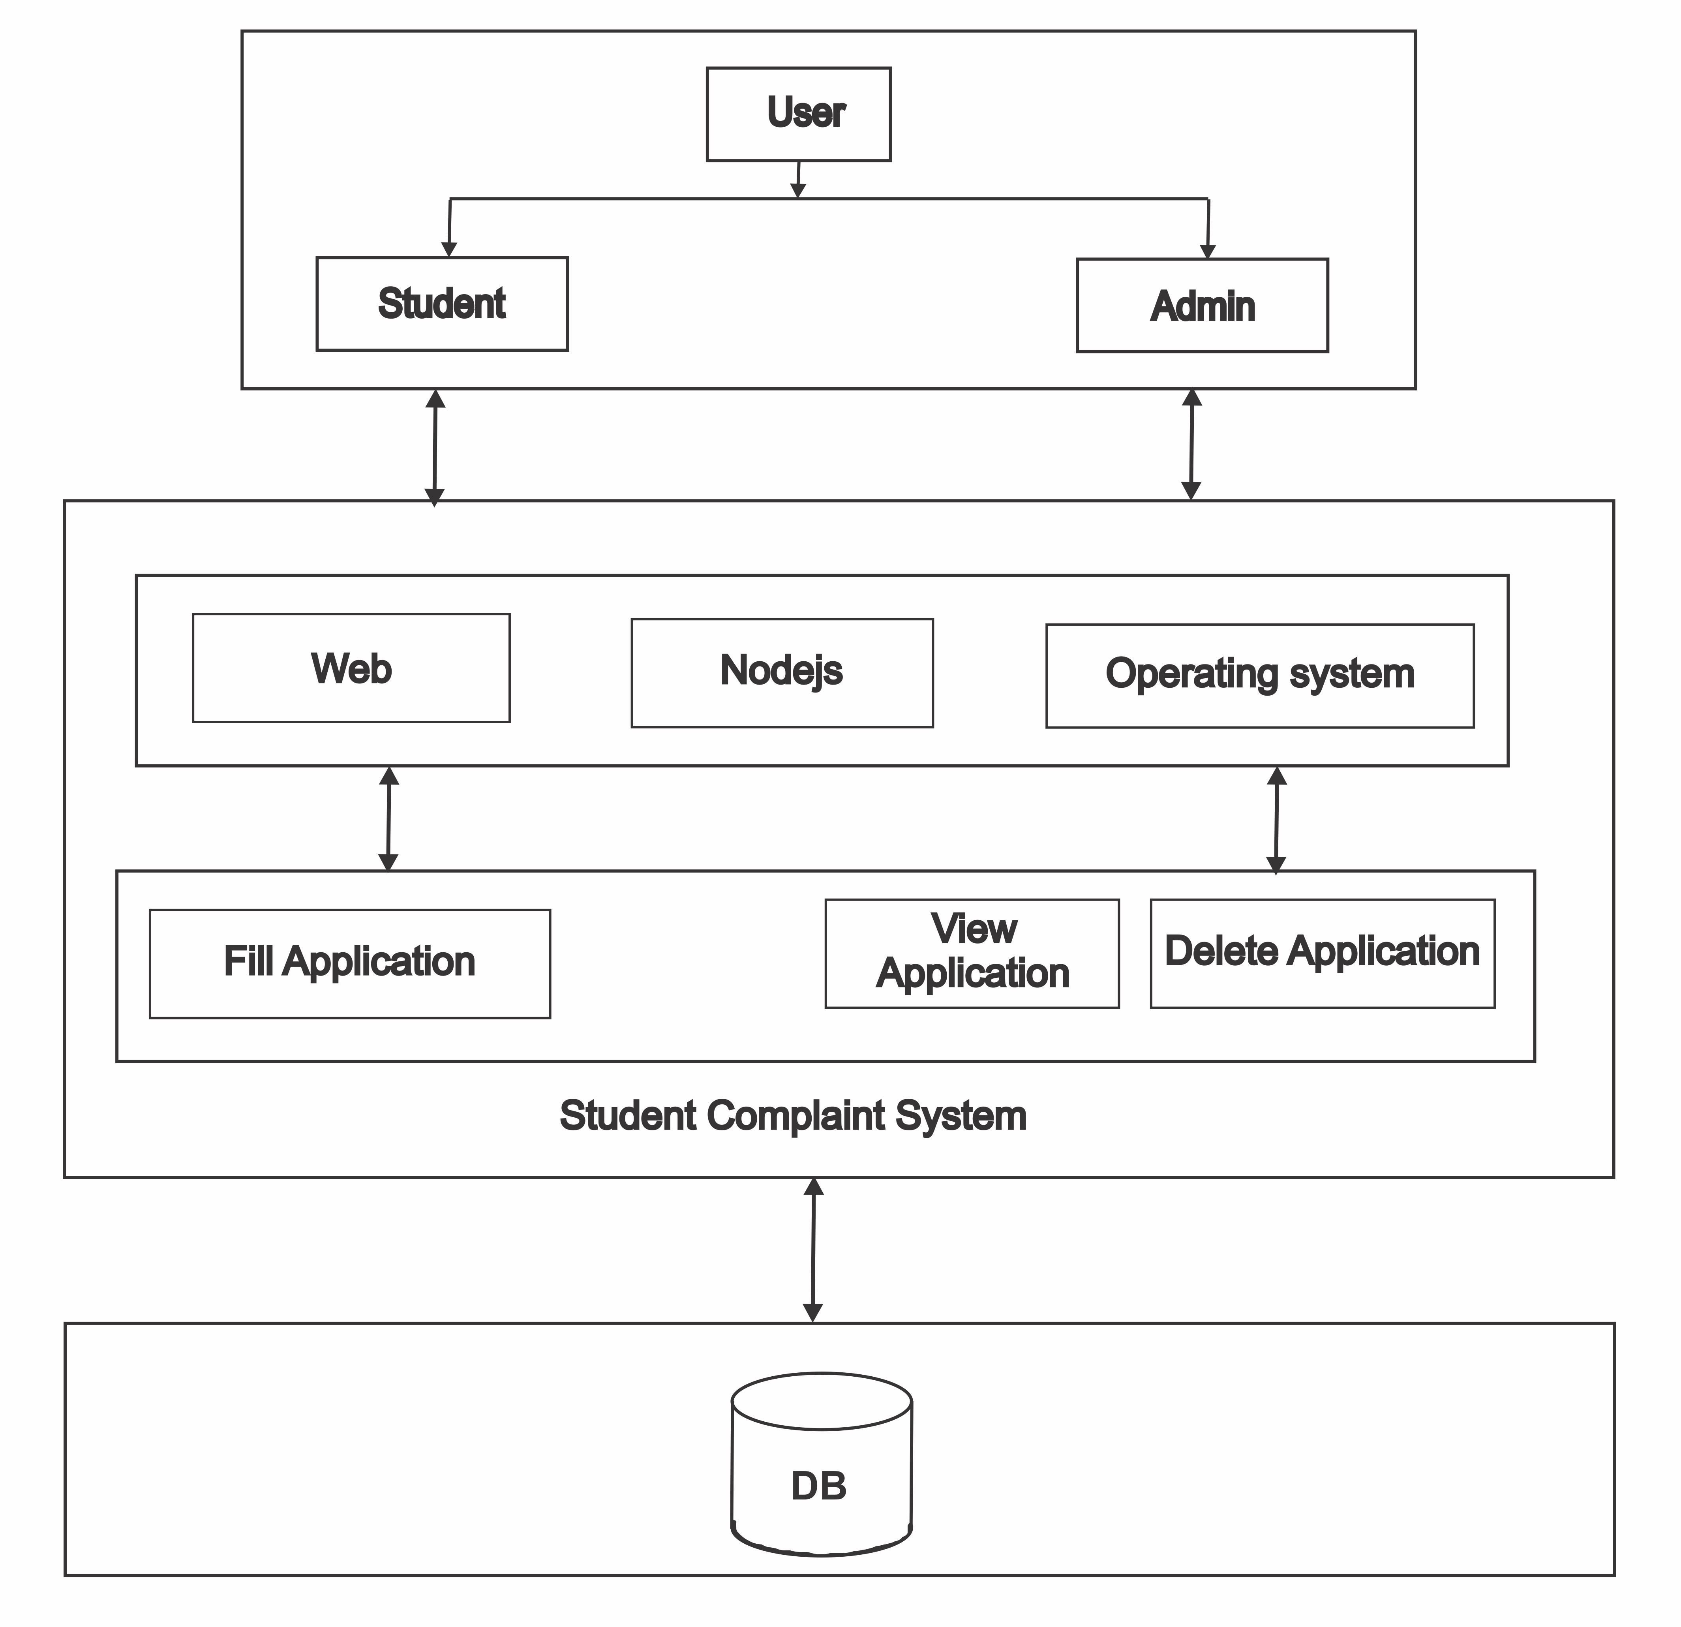

Figure 4.1.4.2: Logical Architecture of the system

* + 1. **Design Model**

**HOME PAGE**

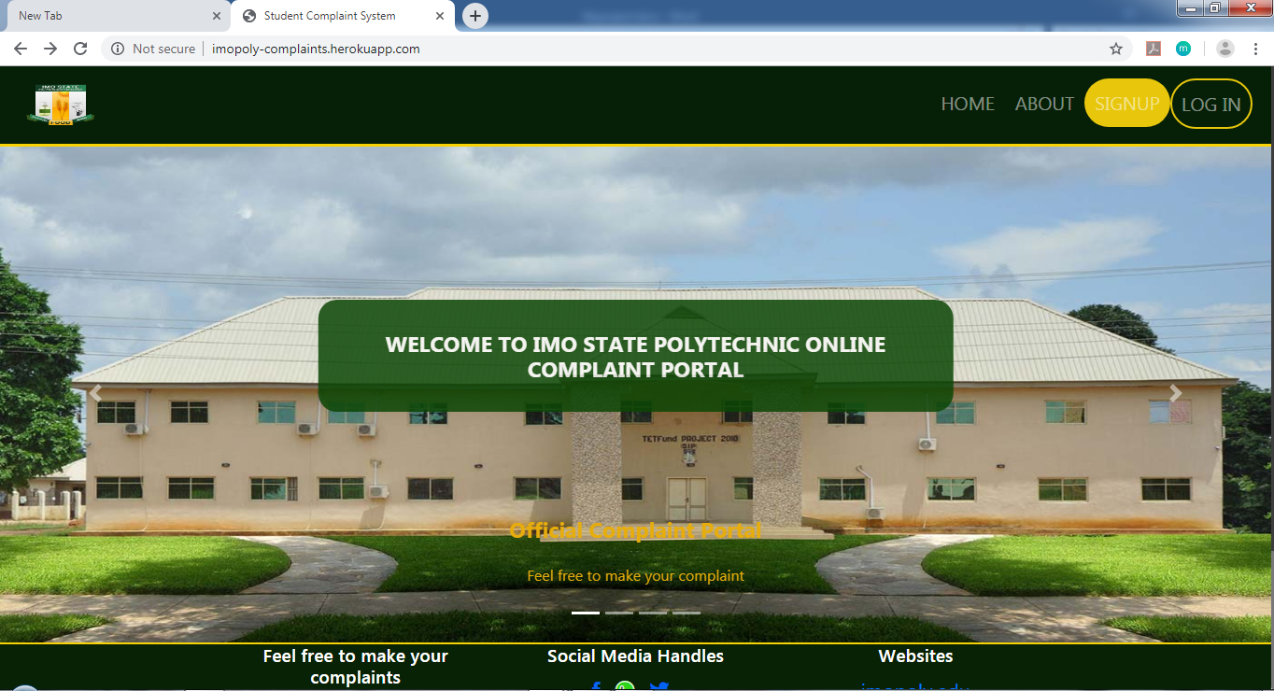

**STUDENT PAGE**

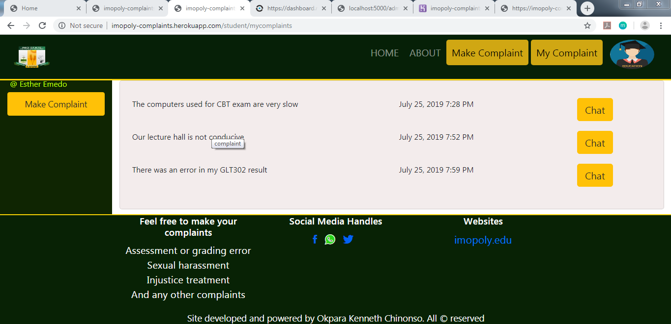

**ADMIN PAGE**

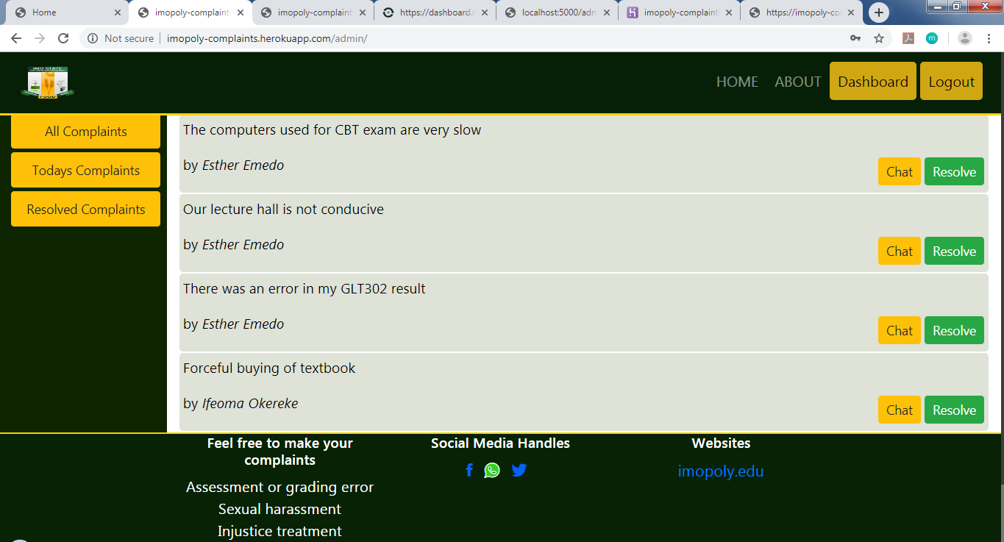

* + 1. **Database Specifications**

There is need to provide an efficient data storage procedure for holding and securing critical information. This data storage module is known as the database. A database is a collection of related data. The database use to implement the back-end of the system is MySql which is in Xampp and Access of the database management system was made possible by phpMyAdmin.

**THE DATABASE CONTAINS FIVE TABLES**

**“admin” Table Structure**

This table holds the information of the Admin.

|  |  |  |  |  |  |
| --- | --- | --- | --- | --- | --- |
| S/N | Field Name | Type | Length | Collation | Extra |
| 1 | admin_id | Int | 3 |  | Auto_increment |
| 2 | Username | Varchar | 30 | latin1_swedish_ci |  |
| 3 | email_address | Varchar | 30 | latin1_swedish_ci |  |
| 4 | Password | Char | 60 | latin1_swedish_ci |  |
| 5 | pictureDir | Varchar | 100 | latin1_swedish_ci |  |
| 6 | user_type | Int | 3 |  |  |

**“complaints” Table Structure**

This table holds all the student’s complaints

|  |  |  |  |  |  |  |
| --- | --- | --- | --- | --- | --- | --- |
| S/N | Field Name | Type |  | Length | Collation | Extra |
| 1 | complaint_id | Int |  | 3 |  | Auto_increment |
| 2 | Complaint | Varchar |  | 500 | latin1_swedish_ci |  |
| 3 | createdAt | Timestamp |  |  |  | Current_Timestamp |
| 4 | Status | Tinyint |  | 1 |  |  |
| 5 | Student_id | Int |  | 3 |  |  |

**“department” Table Structure**

This table holds the department of the student

|  |  |  |  |  |  |
| --- | --- | --- | --- | --- | --- |
| S/N | Field Name | Type | Length | Collation | Extra |
| 1 | dept_id | Int | 3 |  | Auto_increment |
| 2 | dept_name | Varchar | 30 | latin1_swedish_ci |  |

**“post” Table Structure**

This table holds the chatting information of the admin and student

|  |  |  |  |  |  |
| --- | --- | --- | --- | --- | --- |
| S/N | Field Name | Type | Length | Collation | Extra |
| 1 | post_id | Int | 3 |  | Auto_increment |
| 2 | createdAt | Timestamp |  |  | Current_timestamp |
| 3 | Reply | Varchar | 500 | latin1_swedish_ci |  |
| 4 | complaint_id | Int | 3 |  |  |
| 5 | student_id | Int | 3 |  |  |
| 6 | admin_type | Int | 3 |  |  |
| 7 | user_type | Int | 3 |  |  |

**“student” Table Structure**

This table holds the information for the students

|  |  |  |  |  |  |
| --- | --- | --- | --- | --- | --- |
| S/N | Field Name | Type | Length | Collation | Extra |
| 1 | student_id | Int | 3 |  | Auto_increment |
| 2 | Lastname | Varchar | 30 | latin1_swedish_ci |  |
| 3 | Firstname | Varchar | 30 | latin1_swedish_ci |  |
| 4 | Middlename | Varchar | 30 | latin1_swedish_ci |  |
| 5 | Gender | Varchar | 6 | latin1_swedish_ci |  |
| 6 | email_address | Varchar | 40 | latin1_swedish_ci |  |
| 7 | Password | Char | 60 | latin1_swedish_ci |  |
| 8 | Dob | Date |  |  |  |
| 9 | matric_no | Varchar | 30 | latin1_swedish_ci |  |
| 10 | phone_no | Varchar | 20 | latin1_swedish_ci |  |
| 11 | PictureDir | Varchar | 100 | latin1_swedish_ci |  |
| 12 | dept_id | Int | 3 |  |  |
| 13 | user_type | Int | 3 |  |  |

* 1. **Justification of Software Development Tools/Environment Used**

The development tools are the necessary requirement tools used during the design to enable us achieve the system design. The listed packages was used because of their features, accessibility and also because it is more effective.

1. Visual Studio Code
2. MySql database
3. Nodejs

**Visual Studio Code**: Visual Studio Code is a code editor redefined and optimized for building and debugging modern web and cloud applications. It is a lightweight but powerful source code editor developed by Microsoft for Windows, Linux and macOS. The source code is free and open source and released under the permissive MIT License. The compiled binaries are freeware and free for private or commercial use.

**MySQL Database Server:** MySQL is a popular choice for database for use in web applications, and is a central component of the widely used LAMP open source web application software stack. LAMP is an acronym for “Linux, Apache, MySQL, Perl/PHP/Python”. The MySQL Database powers the most demanding Web. It is a fully integrated transaction-safe, ACID compliant database with full commit, rollback, crash recovery and row level locking capabilities. MySQL delivers the ease of use, scalability, and performance that has made MySQL the world’s most popular open source database. It is a Structured Query Language server designed for delivery for heavy loads and processing of complex queries. As a relational database system, MySQL allows many different tables to be joined together for maximum efficiency and speed.

Some of the more popular features of MySQL are as follows:

1. Multiple CPUs usable through kernel threads
2. .Multi-platform operation.
3. Numerous column types cover virtually every type of data.
4. Commands that allow information about the databases to be easily and succinctly shown to management.
5. Function names that do not affect table or column names.
6. A password and user verification system for added security.
7. International error reporting usable in many different countries.

**Nodejs:** Nodejs is an open-source, cross-platform JavaScript run-time environment that executes JavaScript code outside of a browser. Node.js lets developers use JavaScript both for client-side and server-side scripting to produce dynamic web pages content before the page is sent to the user’s web browser. Node.js uses an event-driven, non-blocking I/O model that makes it lightweight and efficient. It has a unique advantage because millions of front-end developers that write JavaScript for the browser are now able to write the server-side code in addition to the client-side code without the need to learn a completely different language. It represents a “JavaScript everywhere” paradigm.

* 1. **System Requirement**

The system requirement deals with both the Hardware and Software Requirements.

**4.3.1 Hardware Requirement**

Hardware is physical components that can make up the computing system (that is everything we can both be seen and touched). Hardware component of the new system include:

* 2.20 GHz Dual-Core CPU Processor
* 4GB RAM.
* 14 super video graphic adapter monitor (SVGA).
* A mouse or mouse sensitive used on laptops.
* Uninterrupted power supply (UPS), lasting for at least 24 hours.

**4.3.2 Software Requirement**

Software is a collection of programs or instructions written in any computer language, which enables flexibility to do whatever the user wants.

This package can be run and developed with the following minimum software requirements;

* Windows 7, 8 or 10 32/64-bit Operating System.
* Xampp Server
* Visual studio code or NotePad++ (Text Editors)
* A compatible browser with network connection for accessing the online module.
  1. **System Testing**

Testing of the software is necessary in order to check the existence of fault in the software so as to make changes that will remove the faults. Testing is necessary to prevent system failure.

During the design stage of the system, testing of the system was done to verify its efficiency and resistance to deliberate errors. The following types of testing was done:

1. **Unit Testing:** This type of testing breaks down the software into components and verifies the functionalities of each individually within the programming environment. Also known as component testing, it tests if each component works as it is supposed to, why it gets the required input and returns the required output.
2. **Integration Testing:** This was done after successfully testing each module of software. Testing is done by creating interfaces between components and making sure that they communicate efficiently and that necessary input and output is transferred for the overall efficient functioning of the system.
3. **Acceptance Testing:** Acceptance testing was done after the implementation of the system. The acceptance testing will check if the system works correctively in the user environment and if all user specified functionalities are present. It also tests if the system adheres to the policies and qualities standard.
   1. **System Maintenance**

System maintenance is the process of maintaining the system by ensuring that it is up and running, it is very important because it is very vital for the smooth running of the system. The online student complaint system will be maintained by doing the following things.

1. Regularly updating the Xampp in the system
2. Regularly checking for code fragments and functionality that has become obsolete.
   1. **System Documentation**

This deals with how the system will be used. The primary user which is the student must register to lay his/her complaint with email address and password which will be verified before accessing the system. The user must follow the user manual to achieve the goal of the system.

**CHAPTER FIVE**

**SUMMARY, CONCLUSION AND RECOMMENDATION**

**5.0 Introduction**

In this chapter, the summary, conclusion and recommendation of this project work will be discussed.

**5.1 Summary**

Online complaint system is a secured system which is used to keep record of student’s complaints in any institution. The system is an automated system that enables quick / easy capturing, processing, and retrieval of prospective student’s complaints.

It also reduces the problems encountered by operating complaint system manually. A complaint management system is an innovation or invention approach to improve the service of the student affairs work and it should be well acknowledged or accepted by the polytechnic in addition to the existing means.

With these advantages, it is a wonderful system which every institution has to introduce as to help them curb and experience these great advantages.

**5.2 Conclusion**

The manual complaint procedure which existed has problems, these problems include; difficulties in storage of complaints, lack of security of students’ complaints, and delay in processing of student complaints.

Too much paper work which generates a lot of records and keeping them can be a problem in a sense that they can be easily mixed up, making retrieval difficult particularly when the appeal are urgently needed for decision-making and lack of security for students’ complaints which can cause loss of student’s complaints and also, timely response is not guaranteed.

In spite of these, we believe the implementation of the new system (online student’s complaint system) especially has advantages of security, timeliness and easy retrieval of students’ complaints which will enable proper complain submitting and control. It will give students verification that their affirmations or issues are usually considered important and properly handled.

It is indeed a wonderful ideal to introduce online complaints system to institution like Imo State Polytechnic Umuagwo.

**5.2 Recommendation**

In other to achieve the objective of online complaint procedures of the institutions, the following recommendations are hereby made;

1. Student Affair Department to commence the process of implementing online student complaints system.
2. Highly skilled professional should be deployed in that unit for better and proper handling of students’ complaints.
3. Proper awareness to be created for students to begin to adopt the electronic means of registering complaints.

**References**

Complaint handling and resolution policy Retrieved 2014 from international Finance Corporation 2121 Pennsylvania avenue NW Washington, dc 20433, USA Five steps in processing complaint mechanism P 20.

M. Leat, (2007) Exploring Employee Relations, Butterworth-Heinemann Publishing, Oxford

Operation of terms Lecturer Definition Retrieved from and <http://www.dictionary.com> Microsoft Encarta Retrieved 2009. Microsoft Corporation.

Marching ton, A. Wilkinson (2005) Automation of web Application by Human Resource Management at Work Chartered Retrieved from Institute of Personnel and Development Publishing, London, 2005.

 Ronald Berenbeim, Non-union Complaint Systems: A Corporate Appraisal (NY: The Conference Board, Report No 770, 1980).

 Mary P. Rowe, PhD, "Are You Hearing Enough Employee Concerns?" with Michael Baker, in Harvard Business Review, Vol. 62, No. 3, (May–June, 1984), pp. 127–136.

Mary P. Rowe, "The Non-Union Complaint System at MIT: An Upward-Feedback Mediation Model," in Alternatives to the High Cost of Litigation, Vol. 2, No. 4, (April, 1984), pp. 10–18.

Ury, William J., Jeanne M. Brett, and Stephen B. Goldberg, Getting Disputes Resolved: Designing Systems to Cut the Costs of Conflict, the Program on Negotiation at Harvard Law School, Cambridge, MA (1993).

Slaikeu. K.A. and R.H. Hasson. (1998). Controlling the costs of conflict: How to design a system for your organization. San Francisco: Jossey-Bass.

DeChurch, L. A; Marks, M. A. (2001). "Maximizing the benefits of task conflict: The role of conflict management". *The International Journal of Conflict Management*. **12**: 4–22. [doi](https://en.wikipedia.org/wiki/Digital_object_identifier):[10.1108/eb022847](https://doi.org/10.1108%2Feb022847).

Kuhn, T.; Poole, M. S. (2000). “Do conflict management styles affect group deciosion making?”. Human Communication Research. 26(4): 558-590. Doi:10.1093.

Blake, R. R., & Mouton, J. S. (1964). The managerial grid. Houston, TX: Gulf.

Rahim, M. A. (2002). "Toward a theory of managing organizational conflict". *The International Journal of Conflict Management*. **13** (3): 206–235.

Pruitt, D. G. (1983). "Strategic choice in negotiation". *American Behavioral Scientist*. **27** (2): 167–194. [doi](https://en.wikipedia.org/wiki/Digital_object_identifier):[10.1177/000276483027002005](https://doi.org/10.1177%2F000276483027002005).

Kozan, M. K. (1997). "Culture and conflict management: A theoretical framework". *The International Journal of Conflict Management*. **8** (4): 338–360.

**APPENDIX I**

**SOURCE CODE**

**Home Page (index.handlebars)**

<div class="container-fluid">

<div id="mySlider" class="carousel slide row" data-ride="carousel">

<!-- Indicators -->

<ul class="carousel-indicators">

<li data-target="#mySlider" data-slide-to="0" class="active">

::before

::after

</li>

<li data-target="#mySlider" data-slide-to="1">

::before

::after

</li>

<li data-target="#mySlider" data-slide-to="2">

::before

::after

</li>

<li data-target="#mySlider" data-slide-to="3"></li>

</ul>

<!-- The slideshow -->

<div class="carousel-inner">

<div class="carousel-item active">

<img src="/img/bee72fe.jpg" alt="depressed student">

<div class="carousel-caption slider-text-container">

<h3 class="slider-text">Official Complaint Portal</h3>

<p class="slider-text">Feel free to make your complaint</p>

</div>

</div>

<div class="carousel-item">

<img src="/img/1.jpg" alt="depressed student" class="slider-img">

<div class="carousel-caption slider-text-container">

<h3 class="slider-text">Any Issue Bothering You</h3>

<p class="slider-text">We are here for you</p>

</div>

</div>

<div class="carousel-item">

<img src="/img/2.jpg" alt="sad student" class="slider-img">

<div class="carousel-caption slider-text-container">

<h3 class="slider-text">Your Complaint Matters</h3>

<p class="slider-text">Please share with us</p>

</div>

</div>

<div class="carousel-item">

<img src="/img/4.jpg" alt="Sad student">

<div class="carousel-caption slider-text-container">

<h3 class="slider-text">Talk To Us</h3>

<p class="slider-text">Your happiness is our top priority</p>

</div>

</div>

</div>

<!-- Left and right controls -->

<a class="carousel-control-prev" href="#mySlider" data-slide="prev">

<span class="carousel-control-prev-icon"></span>

</a>

<a class="carousel-control-next" href="#mySlider" data-slide="next">

<span class="carousel-control-next-icon"></span>

</a>

</div>

</div>

<div class="hero-text">

<h3>WELCOME TO IMO STATE POLYTECHNIC ONLINE COMPLAINT PORTAL</h3>

</div>

**Admin Page**

**(index.handlebars)**

<div class="container-fluid">

<div class="row">

<div class="col-md-2 sidebar ">

<ul class="nav flex-column">

<li class="nav-item mb-1">

<a class="nav-link btn btn-sm btn-warning" href="/admin/">

All Complaints

</a>

</li>

<li class="nav-item">

<a class="nav-link mb-1 btn btn-sm btn-warning" href="/admin/todays/complaints/">

Todays Complaints

</a>

</li>

<li class="nav-item">

<a class="nav-link mb-1 btn btn-sm btn-warning" href="/admin/resolved/complaints/">

Resolved Complaints

</a>

</li>

</ul>

</div>

<div class="col-md-10 main-pane">

{{#if allComplaints}}

{{#each allComplaints}}

<div class="panel">

<p>{{complaint}}</p>

<p>by <em>{{firstName}} {{lastName}}</em></p>

<div class="box-right">

{{#if status}}

<a href="/admin/view/chat/{{id}}" class="btn btn-warning btn-sm">View Chat</a>

{{else}}

<a href="/admin/chat/{{id}}" class="btn btn-warning btn-sm">Chat</a>

<a href="/admin/complaint/resolve/{{id}}" class="btn btn-success btn-sm">Resolve</a>

{{/if}}

</div>

</div>

{{/each}}

{{else if todaysComplaints}}

{{#each todaysComplaints}}

<div class="panel">

<p>{{complaint}}</p>

<p>by <em>{{firstName}} {{lastName}}</em></p>

<div class="box-right">

{{#if status}}

<a href="/admin/view/chat/{{id}}" class="btn btn-warning btn-sm">View Chat</a>

{{else}}

<a href="/admin/chat/{{id}}" class="btn btn-warning btn-sm">Chat</a>

<a href="/admin/complaint/resolve/{{id}}" class="btn btn-success btn-sm">Resolve</a>

{{/if}}

</div>

</div>

{{/each}}

{{else if resolvedComplaints}}

{{#each resolvedComplaints}}

<div class="panel">

<p>{{complaint}}</p>

<p>by <em>{{firstName}} {{lastName}}</em></p>

<div class="box-right">

{{#if status}}

<a href="/admin/view/chat/{{id}}" class="btn btn-warning btn-sm">View Chat</a>

{{else}}

<a href="/admin/chat/{{id}}" class="btn btn-warning btn-sm">Chat</a>

<a href="/admin/complaint/resolve/{{id}}" class="btn btn-success btn-sm">Resolve</a>

{{/if}}

</div>

</div>

{{/each}}

{{else}}

<div class="alert alert-warning">

<a href="#" class="close" data-dismiss="alert">&times;</a>

<p>No data</p>

</div>

{{/if}}

</div>

</div>

</div>

**Student Page**

**myComplaint.handlebars**

<div class="container-fluid p-top">

<div class="row">

<div class="col-md-2 sidebar mx-6 p-bottom">

<!-- sidebar -->

<ul class="nav flex-column">

<li class="nav-item" title="Logged in as">

<a href="/student/index/" class="nav-link active-user">

@ {{user.firstName}} {{user.lastName}}

</a>

</li>

<li class="nav-item">

<a class="nav-link btn btn-sm btn-warning"

href="#" data-toggle="modal" data-target="#complaint">

Make Complaint

</a>

</li>

</ul>

</div>

<div class="col-md-10 main-pane">

<!-- main-pane -->

<div class="card card-body mb-2 mt-2 light-gray" id="complaint">

<h4>{{complaint}}</h4>

{{#each complaints}}

<div class="row mb-3">

<p class="col-sm-6" title="complaint">{{complaint}}</p>

<p class="col-sm-4" title="complaint date">{{createdAt}}</p>

<div class="col-sm-2">

<a href="/student/chat/{{id}}" class="btn btn-warning">

Chat

</a>

</div>

</div>

{{else}}

<p class="col-md-5 mx-auto">You have no Complaints</p>

{{/each}}

</div>

</div>

</div>

</div>

**APPENDIX II**

**SCREEN SHOTS**

**Home Page**



**Student Registration Page**

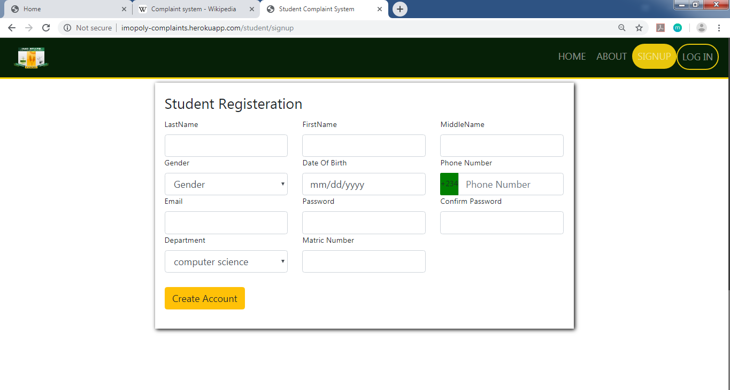

**Student Long-In Page**

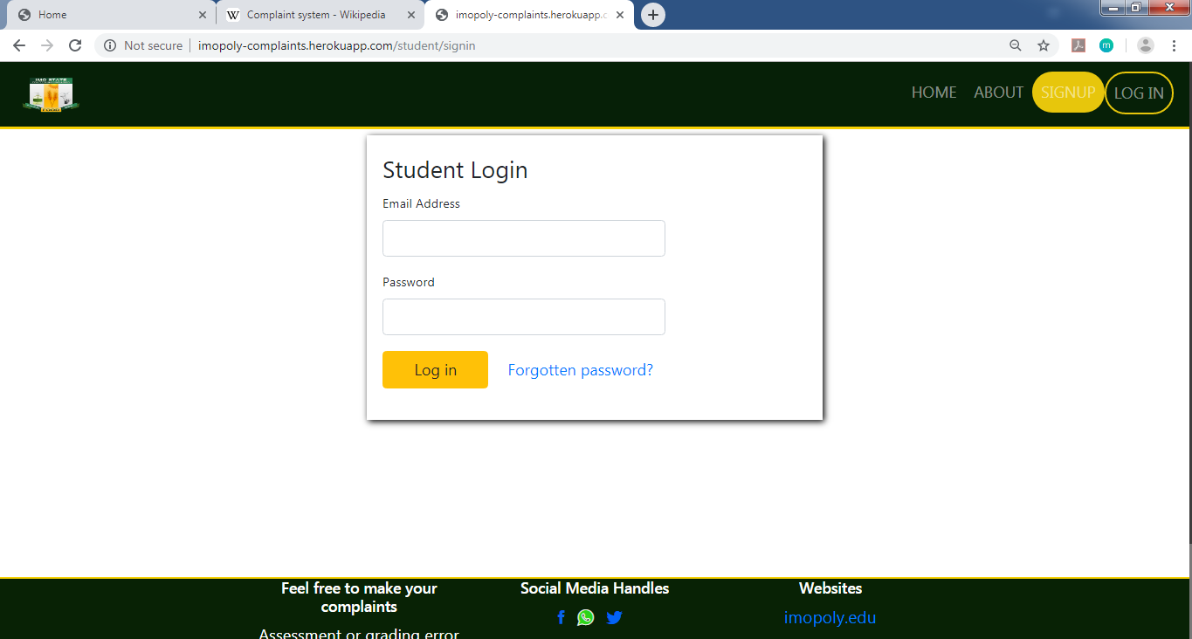

**Student Make Complaint**

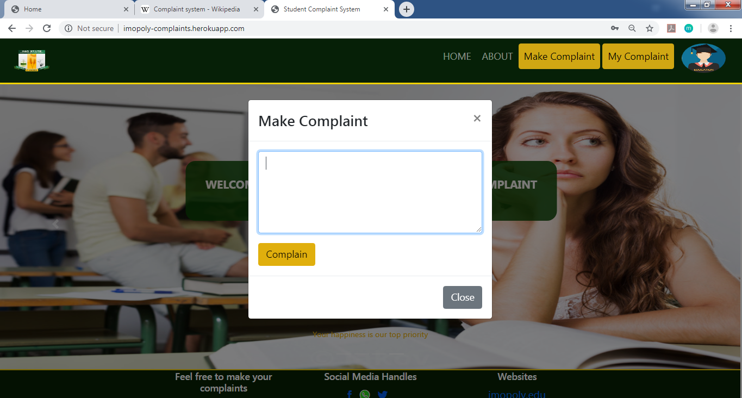

**Student Page**



**Admin Login**

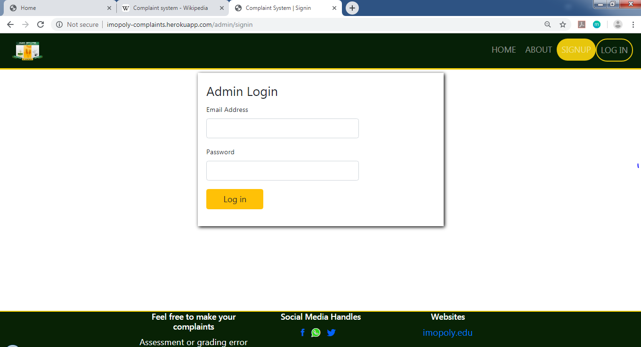

**Admin Page**

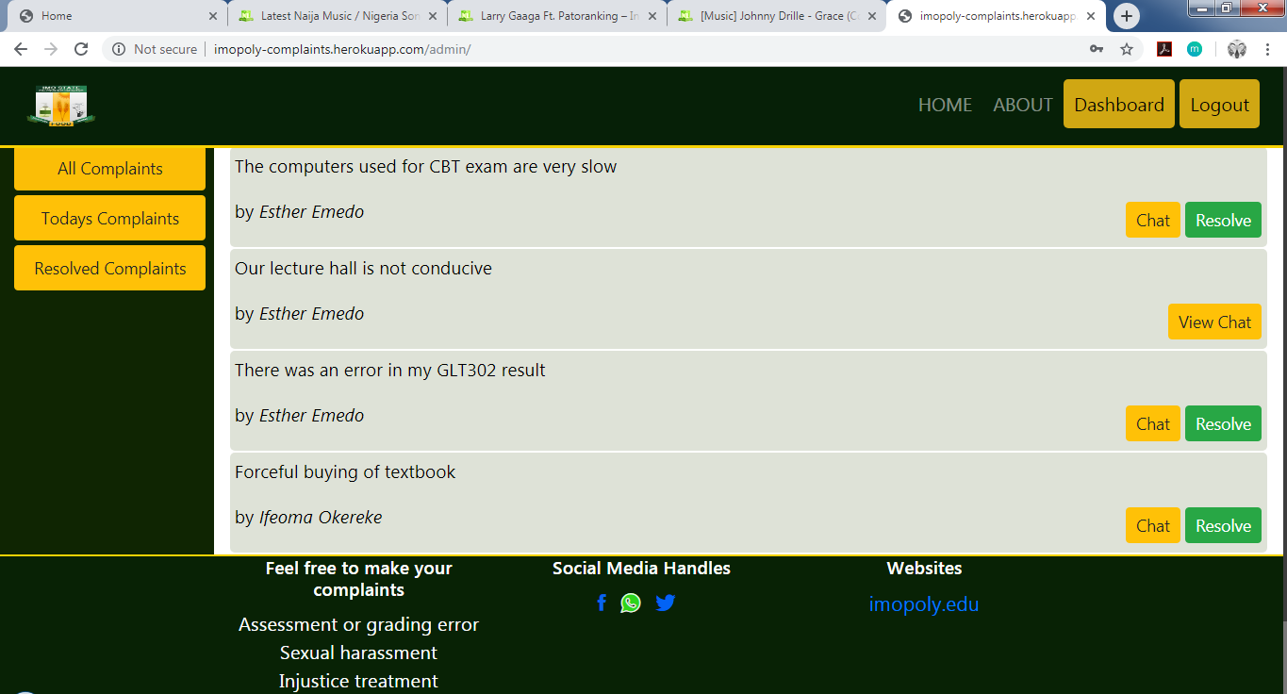

**Student & Admin Chat Page**

